Hashing
- Static HashTable
- Hash Functions:
  - Murmur
  - CRC-64
  - Google CityHash
  - Facebook XXHash (the fastest in the market)
  - Google FarmHash
  - there are also sha256 and md5 but they are used for other purposes
- Hashing Schemes
- Linear Probe hashing: if a colission happens you put the value in the next slot, if the next slot is full you go one more away.
When you delete an element you either mark it(tombstone) as if an element where here, or you move every thing else so that it is in the right place
- Robin Hood Hashing: in this scheme you store with the value how many steps you are away from the place that you are sposed to be in if there is a collision.
On insert you make sure that elements doesn’t move away too much from the its main place.
- Cuckoo Hashing: instead of one hashing table you have two or three, on insert you use the hashing function on the element but with different seed so that it gives you two hash values one for each table, and you put the element in one of the places

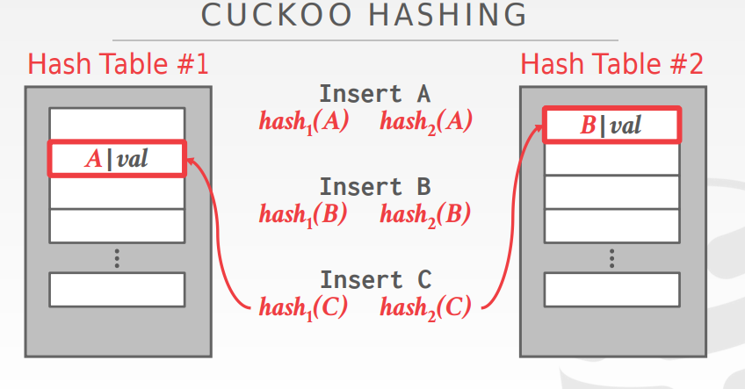

- Dynamic Hashing Scheme
- Chained HashTable (used in java): each slot in the table is a linked list, whenever a collision happens you simply add it to the linked list.
When searching you first hash, then go to the slot, then search in the linked list.
- Extendible Hashing
- Linear Hashing:

